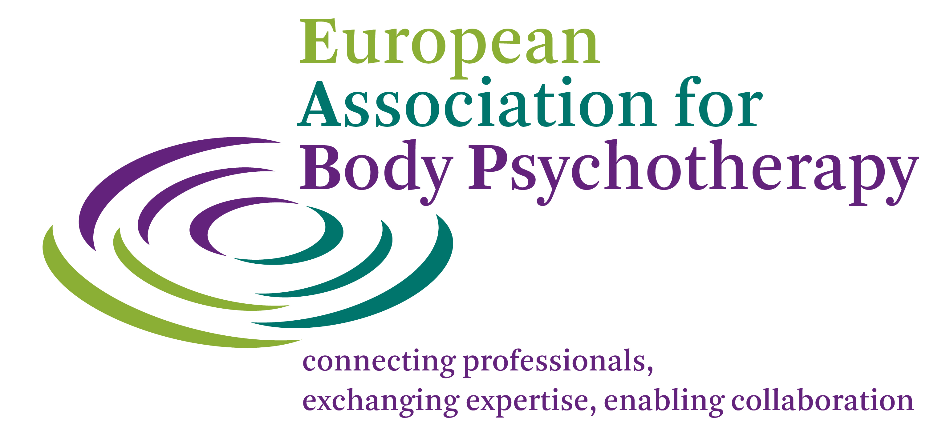

APPLICATION FORM - EABP STUDENT MEMBERSHIP

Please inform yourself about the Student Membership Criteria and Conditions and use the instructions for filling in this application form.

PERSONAL DATA
Name:
Contact Address:

Tel: (including country code)
Email:
Website:
Personal Details:
Date of birth:
Sex:
Languages spoken:
Nationality:
Profession (s):
Other Education:

My reasons for applying

(a) I am in training in Body-Psychotherapy and have not yet fulfilled the full criteria for membership of EABP.
Training Institute:
Website:

(b) I am a student from:
the social science faculties
psychology
medicine
social worker
University & Faculty
Website:

I wish to apply for Student Membership of EABP.

Signed: Date: Place:

Please email your application to:
EABP Secretariat, secretariat@eabp.org
or to the Secretary of the National Association of the country in which you live.
Please provide proof of where you are a student.
On acceptance of membership you will be sent an invoice for the yearly Membership Fee of
30 Euros. When your fee has been paid you will be entered in the Membership database on the EABP (and/or National Association) website (s).

Student Membership is open to students from body-psychotherapy Training Institutes. It is for a period of 5 years. It is also open to students from the social science faculties – psychology and medicine, social workers with an age limit of 28.

